Batch: A3 Roll No.: 1911034
Experiment No. 3
Grade: AA / AB / BB / BC / CC / CD /DD
Signature of the Faculty:

Title: Implementation of polynomials operations (addition, subtraction) using a linked list.

Objective:

To understand the application of Linked list to perform various mathematical operations like addition and subtraction on high power equations easily.

Expected Outcome of Experiment:

CO | Outcome
2 | Use linear and non-linear data structure in domain like compiler construction, DBMS, etc.

Books/ Journals/ Websites referred:

- Data Structures A Pseudocode Approach with C, Richard F. Gilberg & Behrouz A. Forouzan, second edition, CENGAGE learning.

- Data Structures Using C & C++, Rajesh K. Shukla, Wiley- india.

Abstract -- Polynomials are used in both scientific and business-oriented problems. General-Purpose programming languages like C, C++ do not have built-in data types or functions to manipulate polynomials directly. Rather, it is common to represent polynomials using Arrays or Linked Lists. For any polynomial operation linked list representation is most suitable to deal with and handle various mathematical operations on it.

Linked list representation of polynomial of single variables:

In this representation ,

- A single node of the linked list represents one polynomial term of the linked list.

- The coefficient as well as the exponent of each term is stored in the node itself.

- The terms must be entered by the user in the descending order of their exponents.

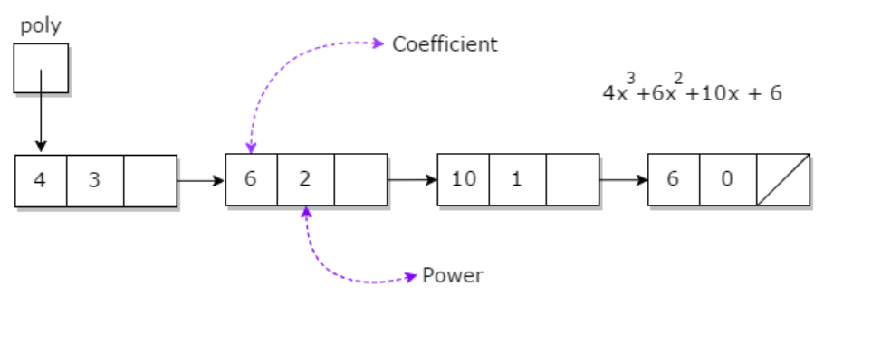

Related Theory:
In computer science, a linked list is a linear collection of data elements whose order is not given by their physical placement in memory. Instead, each element points to the next. It is a data structure consisting of a collection of nodes which together represent a sequence.
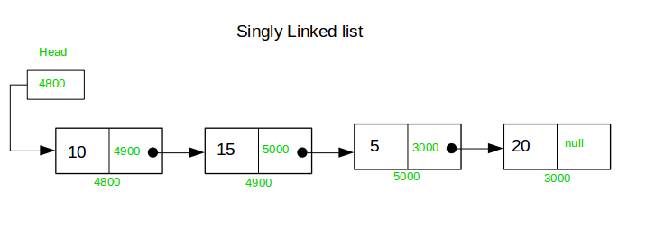

Polynomial is a mathematical expression that consists of variables and coefficients. for example x^2 - 4x + 7
In the Polynomial linked list, the coefficients and exponents of the polynomial are defined as the data node of the list.
For adding two polynomials that are stored as a linked list. We need to add the coefficients of variables with the same power. In a linked list node contains 3 members, coefficient value link to the next node.
a linked list that is used to store Polynomial looks like −
Polynomial : 4x⁷ + 12x² + 45
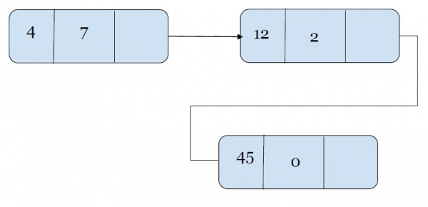
This is how a linked list represented polynomial looks like.
Adding two polynomials that are represented by a linked list. We check values at the exponent value of the node. For the same values of exponent, we will add the coefficients.

Example of addition of polynomials using a Linked List
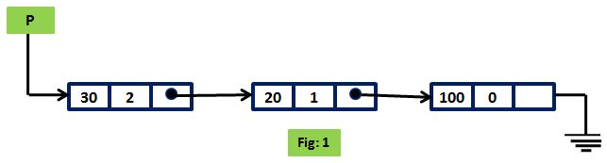
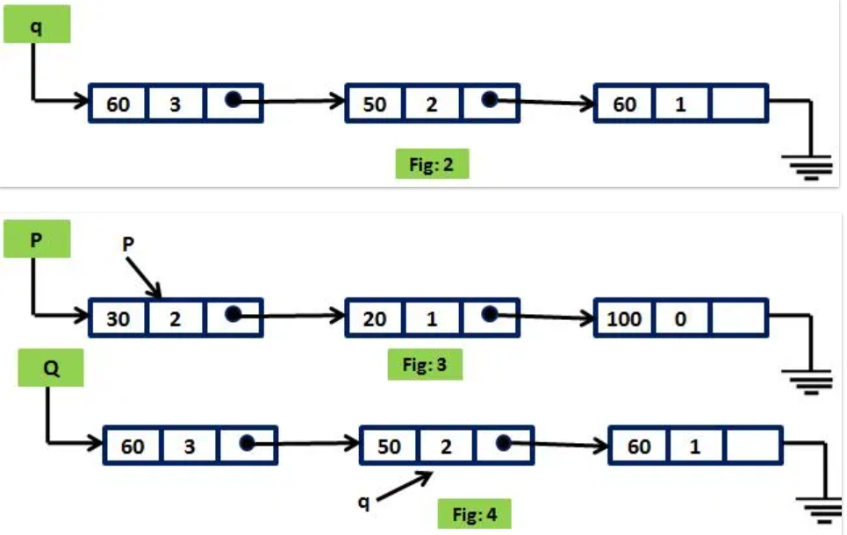
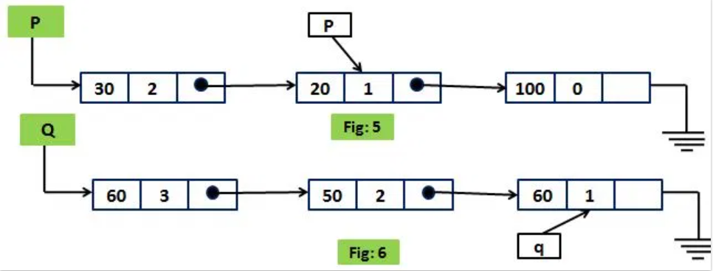
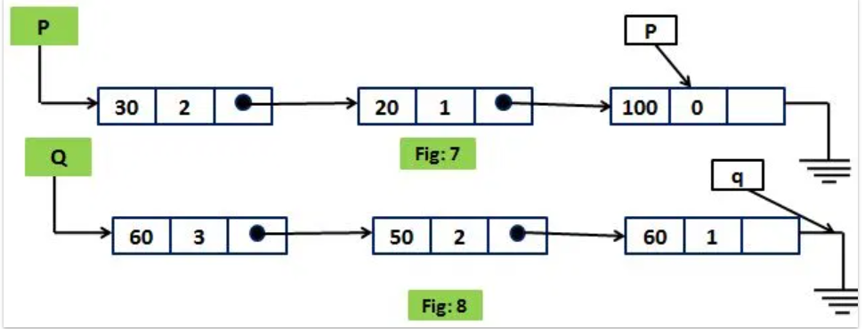

Diagram for linked representation of polynomial of single variables:

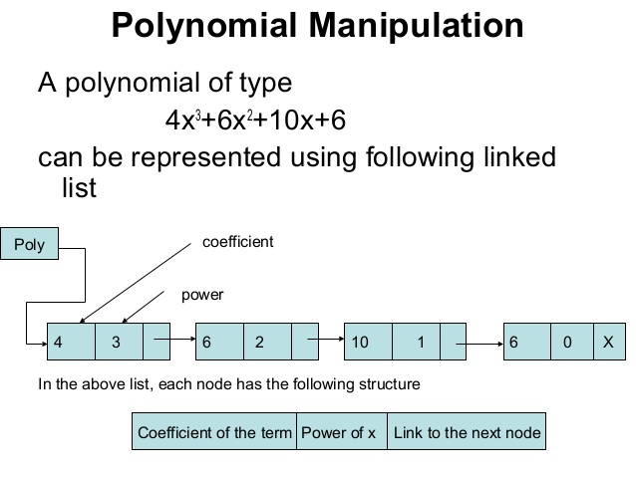

Algorithms for mathematical operations on polynomials:
- Algorithm for the addition of two polynomials :
Step1: accept the two polynomials in the linked list format from the user , by calling the readpoly() function , and pass them to the function addpoly () , which will return a new linked list that will return a polynomial which will be the result of the addition.
Step 2: In the function , addpoly (), initialize two pointers of struct polynode type , *p and *q , which point to the heads of the first and second polynomials respectively , and *pa , which points to the head of the added polynomial.
Step3 : Repeat from steps step ‘4’ to step ‘7’ , till either *p!=NULL , OR *q!=NULL.
Step4: if (p->exp == q-> exp), then perform the step 5.
Step5 : set coef = p->coef +q->coef, exp = p->exp , and call the AddEnd() function with the parameters (*pa,coef,exp).
Step6 : else if (p->exp>q->exp), set coef = p->coef , exp = p->exp , and call the AddEnd() function with the parameters (*pa,coef,exp). Then set p = p->next
Step 7: else if (q->exp>p->exp), set coef = q->coef , exp = q->exp , and call the AddEnd() function with the parameters (*pa,coef,exp). Then set q = q->next
Step8: If (p==NULL), repeat step 9 , till q!=NULL.
Step 9: set exp = q->exp, set coef = p->coef, and call the AddEnd() function with the parameters (*pa,coef,exp).
Step 10: : If (q==NULL), repeat step 11 , till p!=NULL.
Step 11: set exp = p->exp, set coef = p->coef, and call the AddEnd() function with the parameters (*pa,coef,exp).
Step 12 : The node *pa , now contains the added polynomial expression in linked list form , which can be returned to the main function , and it can be displayed by calling the display() function.
Algorithm for the Subtraction of two polynomials :
Step1: accept the two polynomials in the linked list format from the user , by calling the readpoly() function , and pass them to the function subpoly () , which will return a new linked list that will return a polynomial which will be the result of the subtraction.
Step 2: In the function , subpoly (), initialize two pointers of struct polynode type , *p and *q , which point to the heads of the first and second polynomials respectively , and *ps , which points to the head of the resultant polynomial.
Step3 : Repeat from steps step ‘4’ to step ‘7’ , till either *p!=NULL , OR *q!=NULL.
Step4: if (p->exp == q-> exp), then perform the step 5.
Step5 : set coef = p->coef - q->coef, exp = p->exp , and call the AddEnd() function with the parameters (*ps,coef,exp).
Step6 : else if (p->exp>q->exp), set coef = p->coef , exp = p->exp , and call the AddEnd() function with the parameters (*ps,coef,exp). Then set p = p->next
Step 7: else if (q->exp>p->exp), set coef = q->coef , exp = q->exp , and call the AddEnd() function with the parameters (*ps,coef,exp). Then set q = q->next
Step8: If (p==NULL), repeat step 9 , till q!=NULL.
Step 9: set exp = q->exp, set coef = p->coef, and call the AddEnd() function with the parameters (*ps,coef,exp).
Step 10: : If (q==NULL), repeat step 11 , till p!=NULL.
Step 11: set exp = p->exp, set coef = p->coef, and call the AddEnd() function with the parameters (*ps,coef,exp).
Step 12 : The node *ps, now contains the resultant polynomial expression in linked list form , which can be returned to the main function , and it can be displayed by calling the display() function.

Program to Add/Subtract Two Polynomials :

#include <stdio.h>
#include<stdlib.h>

struct polynode
{
int coef;
int exp;
struct polynode*next;
};
struct polynode*AddEnd(struct polynode*,int , int);
struct polynode *readpoly()
{
struct polynode *temp,*temp1,*p1;
p1=NULL;

int i,c,e,n;
printf("Enter the number of terms of the polynomial\n");
scanf("%d",&n);
for(i=0;i<n;i++)
{
printf("Enter the coeff\n");
scanf("%d",&c);
printf("Enter the exponent\n");
scanf("%d",&e);
p1= AddEnd(p1,c,e);

}
return p1;
}

void display(struct polynode*p1)
{
struct polynode*temp,*temp1;
temp= p1;
while(temp!=NULL)
{
printf("%d",temp->coef);
if(temp->exp!=0&&temp->exp!=1&&temp->coef!=0)
{
printf("x^");
printf("%d",temp->exp);
}
else if(temp->exp==1)
{
printf("x");
}

if(temp->next!=NULL)
{
temp1=temp->next;
if(temp1->coef>0)
{
printf("+");

}

}

temp= temp->next;

}
printf("\n");
}

struct polynode*addpoly(struct polynode*p1, struct polynode*p2,struct polynode*pa)
{
struct polynode*p,*q;
struct polynode *newnode=NULL;

int e,c;
p=p1; q=p2;
while((p!=NULL)&&(q!=NULL))
{

if((p->exp==q->exp)&&(p->coef+q->coef!=0))
{
e=p->exp;
c= p->coef+q->coef;
p=p->next;
q=q->next;
newnode = AddEnd(newnode,c,e);
}

else if(p->exp>q->exp)
{
e = p->exp;
c = p->coef;
p=p->next;
newnode = AddEnd(newnode,c,e);
}

else if(q->exp>p->exp)
{
e = q->exp;
c = q->coef;
q=q->next;
newnode = AddEnd(newnode,c,e);
}

}

if(p==NULL)
{
while(q!=NULL)
{
e = q->exp;
c =0- q->coef;
q=q->next;
newnode = AddEnd(newnode,c,e);
}
}
else if (q==NULL)
{
while(p!=NULL)
{
e = p->exp;
c = p->coef;
p=p->next;
newnode = AddEnd(newnode,c,e);
}
}
return newnode;
}

struct polynode*subpoly(struct polynode*p1, struct polynode*p2,struct polynode*pa)
{
struct polynode*p,*q;
struct polynode *newnode=NULL;

int e,c;
p=p1; q=p2;
while((p!=NULL)&&(q!=NULL))
{

if((p->exp==q->exp)&&(p->exp+q->exp!=0))
{
e=p->exp;
c= p->coef-q->coef;
p=p->next;
q=q->next;
newnode = AddEnd(newnode,c,e);
}

else if(p->exp>q->exp)
{
e = p->exp;
c = p->coef;
p=p->next;
newnode = AddEnd(newnode,c,e);
}

else if(q->exp>p->exp)
{
e = q->exp;
c = 0-q->coef;
q=q->next;
newnode = AddEnd(newnode,c,e);
}

}

if(p==NULL)
{
while(q!=NULL)
{
e = q->exp;
c = q->coef;
q=q->next;
newnode = AddEnd(newnode,c,e);
}
}
else if (q==NULL)
{
while(p!=NULL)
{
e = p->exp;
c = p->coef;
p=p->next;
newnode = AddEnd(newnode,c,e);
}
}
return newnode;
}

struct polynode*AddEnd(struct polynode*p, int c, int e)
{
struct polynode*temp,*temp1;
temp = (struct polynode *)malloc(sizeof(struct polynode));
temp->coef = c;
temp->exp = e;
temp->next = NULL;
if(p==NULL)
{
p = temp;
}
else
{
temp1= p;
while(temp1->next!=NULL)
{
temp1 = temp1->next;

}
temp1->next = temp;
temp->next = NULL;

}
return p;
}

int main(void) {

printf("Hello World\n");
struct polynode *p1,*p2,*pa,*ps;
p1= NULL; p2 = NULL; pa = NULL; ps=NULL;
p1 = readpoly();
display(p1);
p2=readpoly();
display(p2);
printf("ADDITION:\n");
pa= addpoly(p1,p2,pa);
display(pa);
printf("SUBTRACTION:\n");
ps= subpoly(p1,p2,ps);
display(ps);
return 0;
}

Screenshot of Output

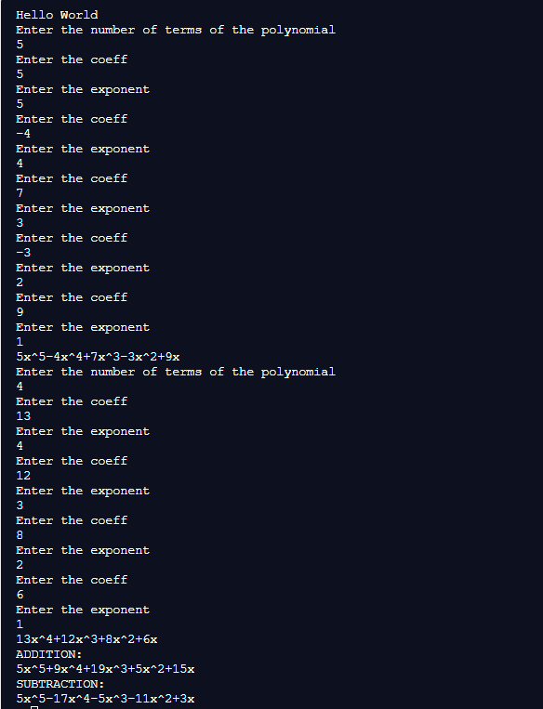

Implementation Details:
- Enlist all the Steps followed and various options explored.
Steps followed :

- First we accept the two polynomials from the user , by asking for the number of terms of each polynomial , and then passing the control to the readpoly() function.
- In the readpoly() function , we then ask the user to enter the coefficient and exponent of each term , and we dynamically allot a node to each term of the polynomial , by calling the AddEnd() function.
- After reading each polynomial , it is displayed by calling the display() function.
- Now , we perform the addition or the subtraction of the two polynomials , by calling the addpoly() or the subpoly() functions , and perform the addition and subtraction operations according to the algorithms as described above.
- Finally ,we display the result of the operation of addition/subtraction operations by calling the display() function accordingly.

- Explain your program logic, classes and methods used.

Program logic

- The whole program works along the lines of dynamic allocation of nodes to the linked list , be it during the reading of the polynomial or during the addition /subtraction of polynomials
- The displaypoly() function has certain steps to ensure that the polynomials are displayed in a proper format.
- For example , to avoid displaying the ‘+’ sign at the end of every polynomial , we run a variable ‘temp’ , until it reaches the second last node and print the plus sign only upto after the second last node.
- We have also taken care to ensure that the ‘+’ sign after the reading of terms is displayed only if the coefficient of a particular term is positive , by putting the while loop for printing the ‘+’ inside an ‘if’ statement.
- As the program runs sequentially , it calls the read()-add()/subtract() and display(0 functions in that order.

Classes : no classes were used

Methods used : struct polynode*AddEnd(struct polynode*,int , int);
struct polynode* readpoly()
struct polynode*addpoly(struct polynode*p1, struct polynode*p2, struct polynode*pa)
struct polynode*subpoly(struct polynode*p1, struct polynode*p2, struct polynode*ps)
void display(struct polynode*p1)

3. Explain the Importance of the approach followed by you.

In this approach :
- We have learnt and implemented the dynamic allocation of nodes of the linked list , which can be very useful for saving memory , as opposed to arrays.
- Due to dynamic allocation , we have also been able to create the nodes as per the requirement of the number of terms of the polynomial .
- We have applied the logic for all the edge cases and special cases that may occur while displaying the polynomial , or during addition/subtraction.
- We have learnt how the application of linked list can be useful for solving real-world problems like performing mathematical operations on polynomials.

Conclusion:
In this experiment ,we have learnt about the applications of linked list , and the dynamic allocation of nodes in a linked list for performing real world operations such as polynomial addition/subtraction. We have been able to write a program that considers all the cases that might occur while the addition of polynomials and have also implemented a function to display the result.

